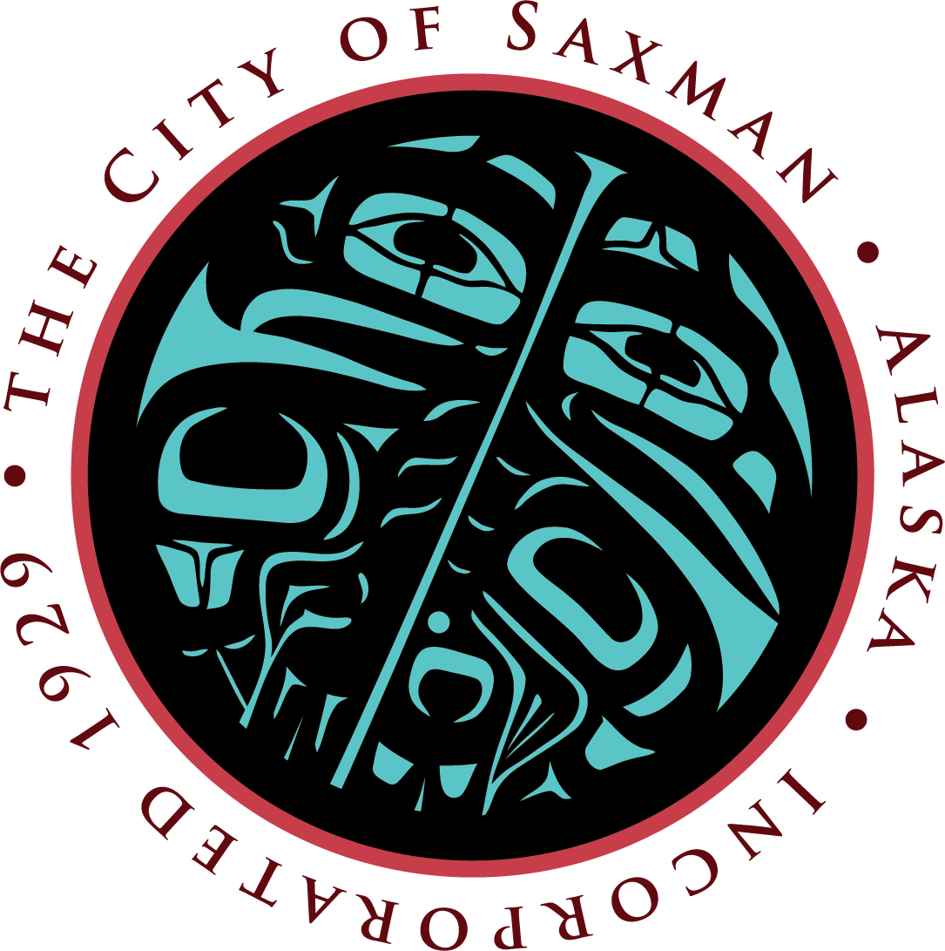
Presented on behalf of the City of Saxman City Council
Request for Commercial PAssenger Vessel Funding

Lori Richmond, City Administrator

Request for Commercial Passenger Vessel (CPV) Funding
for a new Totem Park and Native Village master plan

To the attention of the Ketchikan Gateway Borough Assembly,

Please find attached a formal request for CPV funds for an updated Master Plan for the Totem Park and proposed Native Village attraction.
Saxman has the largest collection of totem poles in the world. Residents are committed to their cultural ways and equally committed to sharing those stories with others. A cohesive setting is integral for presenting this native historical site to the visitors of the Ketchikan Gateway Borough.
In an organized and well planned setting the citizens of the City of Saxman can present activities and programs that are diverse enough to interest visitors and guests for many return visits
Careful planning will ease some of the over-crowding in the City of Ketchikan. An updated Master Plan will give a much-needed injection of revenue to the economy of Saxman and the surrounding area.
Beyond accommodating visitors and guests in the Park and Village, the City can accommodate the cruise ship industry with a proper wastewater disposal system.
When Saxman is successful the entire area is successful.

Thank you for your careful consideration of this request.

Respectfully,
Lori Richmond on behalf of the Saxman City Council
City Administrator

Attachments: Apportionment Table, Corvus Master Plan Estimate, Existing Master Plan

Current Trends
October 29, 2019 was a point of change for the Saxman City Council. They met for two days, morning to night, and discussed the future of Saxman. The Council, together, decided that the current direction of Saxman should be maximizing resources such as Saxman owned tidelands, rich heritage and history, and diverse outdoor environment.
The Council decided that developing tourism and enhancing visitor environments should be front and center. The Council created the first Mission Statement, Vision Statement, Guiding Values and a City motto and approved them by resolution.
They approved a new logo set and spending on marketing and business development.
The City has commissioned a Seaport Master Plan. A tourism Master Plan is the next step.

City of Saxman Mission Statement:
The City of Saxman is dedicated to cultivating a safe and cost-effective infrastructure for the guests and residents of Saxman while improving the quality of life for all.

City of Saxman Vision Statement:
To nurture Saxman’s economic growth while preserving the community’s resources and sharing our cultural past.

Guiding Values:
Culture:
We cherish our living culture daily by working hard for all peoples.
Respect for all people:
We commit to respecting all people and their way of life.
Transparency:
We operate in a way that creates openness between the government and its people.
Unity:
The strength of our community is when we are in harmony as one.

Project Description:
The most recent master plan developed for Saxman was the 1989 Native Village Master Plan. The 1989 plan is out of date. It does not consider Saxman’s involvement in the borough both economically and physically. Updating it will allow the City to respond to current needs and opportunities.
In the last thirty years there have been significant changes to the resources available for revenue in the City of Saxman. As the Council considers longevity for the City budget it must consider the cruise ship industry, desired visitor experiences, and the increase in demand to visit Saxman. These needs are not recognized by the 1989 plan.
The City of Saxman is visited annually by approximately 151,868 cruise ship passengers and there are opportunities to provide new services and minimize impacts from existing and proposed improvements.
A new master plan for the Saxman waterfront and Totem Park is needed to guide future development, understand construction costs for improvements, and to develop an implementation plan that responds to current and future needs and opportunities for tourism growth.
A new master plan will accomplish the following:
- Develop a new small cruise ship dock including related uplands;
- Develop a new harbor for water-based tour experiences;
- Develop Park facilities that provide new cultural experiences to celebrate our native heritage;
- Develop new recreation opportunities for visitors;
- Improve transportation systems (pedestrian and vehicular);
- Create a cohesive and authentic master plan for the Saxman Native Village;
- Provide economic opportunities for those that live in Saxman and the surrounding areas;
- Provide an enhanced visitor experience; and
- Provide an implementation plan and a critical tool for obtaining the needed funding for improvements.
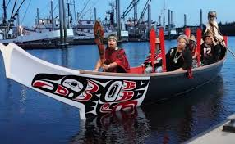
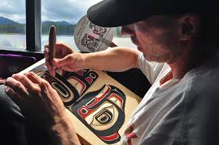
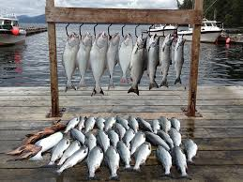
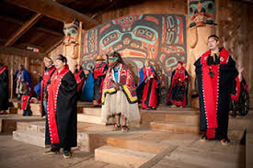
A collection of local heritage activities. All can be found in Saxman.

Request:
The City of Saxman is requesting $108,699.00 to update the master plan for the Saxman Native Village. The master plan update would include facilities that directly benefit the cruise ship industry. This includes a new harbor, small cruise ship docking, related uplands, recreation and cultural opportunities as well as transportation improvements. Many of these improvements were not included in the 1989 master plan and need to be included in the update.
Corvis Design Company has created an estimate for an all-inclusive Master Plan that will include immediate as well as future improvements.
Part of the services the City is requesting CPV funds for are renderings of an updated park and harbor that would allow the City to have informed conversations with other funding sources.
The City understands that the KGB has established a policy of apportioning costs between residents and visitors based on their proportion of overall use. The following page shows a realistic breakdown of this proportion.

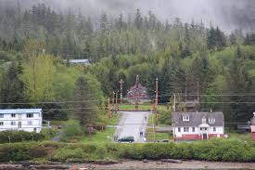
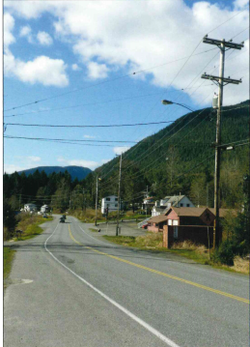
Current Views of Saxman

Benefits:
Developing an updated master plan will benefit Saxman and the Ketchikan Gateway Borough in the following ways:
- Provide the needed docking and uplands facilities for small cruise ships (230-240 feet) and provide the needed support facilities for ships and passengers;
- The City of Saxman envisions including handling of waste from cruise ships (grey water and sewer) as a requirement for docking, offering a real solution for dealing with wastewater;
- There is an industry wide growing demand for “heritage tourism” style excursions. Saxman is in a unique position, both with its partnership with Cape Fox and in location to offer many styles of these types of excursions and meet this demand;
- The harbor would allow direct access to vessels providing charter fishing and other water-based excursions and reduce congestion in the downtown Ketchikan harbors;
- The master plan would provide the needed marketing and business development plan for the Saxman Native Village and Totem Park;
- Provide revenue for the City of Saxman to provide needed services for the elders, children and anyone who chooses to make Saxman their home; and
- Create new jobs and economic opportunities for new businesses in Saxman in conjunction with the improvements in the master plan.

Partnerships: Our request is not for the entire amount of this master planning effort rather the portion related to facilities that meet the needs of the cruise ship industry and its passengers. Components in the master plan that are beyond the industry are being funded by other partnerships including the City of Saxman, Cape Fox, and others.

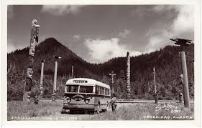
Right: Post card of tour bus arriving at Totem Park. Unkn year
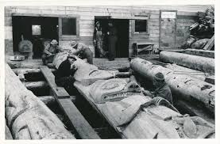
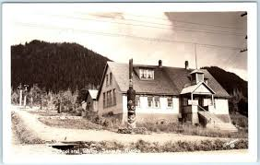
Left: Saxman School House ca. 1938

Above: Wood carvers restore the Ebbits or Dogfish Pole ca. 1939

